External Datasources

Configure BlueDragon

- In BlueDragon Administration, click on data sources.
http://vmsales:8080/bluedragon/admin/index.cfm PW: sysadmin

Example 1
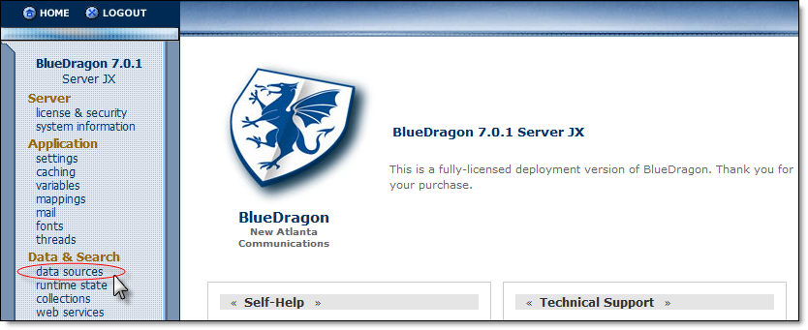

- Click Add Datasource

- Add a Datasource Name. The name entered must be composed of the Company ID (as defined in MasterControl) followed by the word ‘External’. To find the Company ID in MasterControl, click MasterControl Portal > System Settings > System Information. The Company ID will be displayed as part of the Application Variables:

Example 2
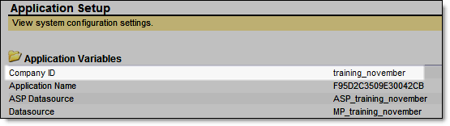
In this case, the Datasource Name would need to be ‘training_novemberExternal’. If multiple Datasources are needed (to connect to multiple databases), additional text may be appended to the end of the Datasource Name.
Examples:
training_novemberExternal_Northwind
training_novemberExternalERP
training_novemberExternalCRM_System

- Once the Datasource Name and the rest of the information (e.g. Database name, server location, credentials, etc.) has been entered, the Datasource can be referenced in MasterControl.

Configure MasterControl

- In MasterControl, click MasterControl Portal > System Settings > External Datasources. Click New to create a new Datasource.

The Name is an arbitrary name that will be referenced in the PDF form.
The Source is the name of the Datasource just created in BlueDragon.
The Statement is a SQL statement used to retrieve the data.

There are two types of External Datasources that can be created, which relate to the two different keywords available for use in the PDF form: mastercontrol.set.name, and mastercontrol.pset.name.

mastercontrol.set.name

When a PDF combo or list box is named mastercontrol.set.name, the system will automatically populate the combo or list box with the results of the query (as specified in the Statement). This keyword is used to return a single column of information from a table. Note the syntax of the Statement: SELECT column name FROM table name

Example 3
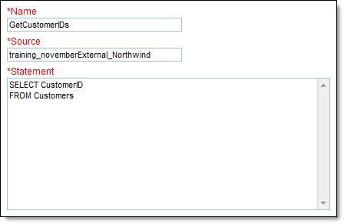

Once this is saved, click the Preview icon to view the first 15 results of the query:

Example 4
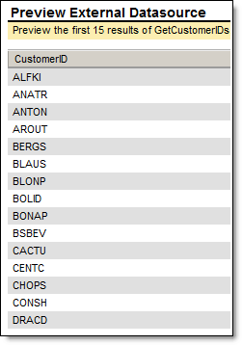

To incorporate this into a form, create a combo or list box named ‘mastercontrol.set.’ plus the Name from the External Datasource above:

Example 5
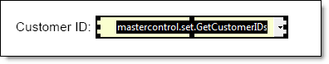

When the form is launched within MasterControl, the combo or list box will be populated with the results of the query:

Example 6

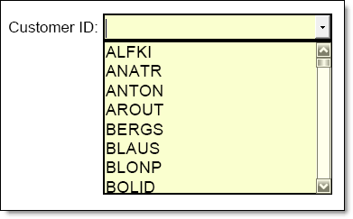

mastercontrol.pset.name

Form fields can be automatically populated based on the result of a parameterized query. In the following example, the user would enter a Customer ID and then click the ‘Search By ID’ button. MasterControl would execute a database query that found the Customer ID and retrieved the related Address and City. The values of Address and City would then be automatically populated in the form.

Example 7
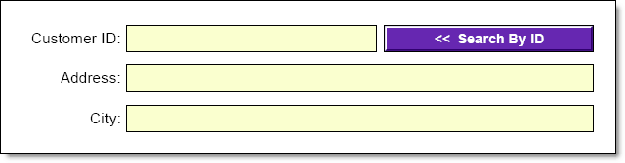

To create a parameterized query, click MasterControl Portal > Configuration > External Datasources. Click New to create a new Datasource.
The Name and Source are entered as before. The Statement will be different, as follows:

Example 8
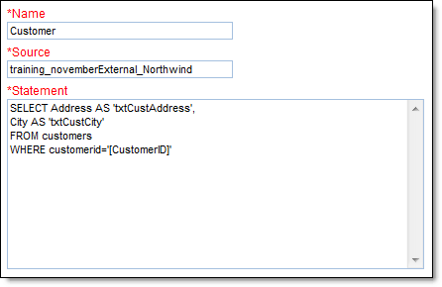

The syntax of the statement is as follows:
SELECT columnX name AS ‘fieldX in the form that you want auto-populated’
FROM table_name
WHERE column_name = ‘[keyworded field name that contains parameter]’

A parameterized query requires two keyworded fields in the PDF form: The first field (to contain the parameter), and a button that will be clicked to trigger the query.
The first field must be named mastercontrol.pset. Datasource_name.arbitrary_name_referenced_in_query
The button must be named mastercontrol.pset.Datasource_name.submit

Example 9
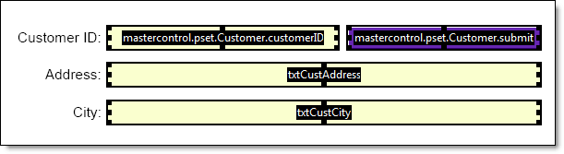

When the user enters a valid Customer ID and clicks the ‘Search By ID’ button, the form refreshed to show the Address and City populated with the related values from the database.

Example 10
